Security IMPOSSIBLE
Digital Forensics Report Writing Lab
Question and Scenario Booklet
Angie Knight
8/20/2024

Scenario
XYZ Bank provides net-banking services to its customers. On April 2nd, 2014, while conducting an online transaction, Alex Smith, a customer of XYZ Bank, noticed a subtle change in the bank's payment authorization form. The form was now requesting additional information that had not been required before. Believing that the changes were a routine update to comply with recent government regulations, Alex Smith filled out the extra fields without hesitation.
However, within the next four days, Alex Smith discovered that over $200,000 had been withdrawn—and subsequently stolen—from her account. Alarmed by the unauthorized transactions, Alex immediately lodged a complaint with XYZ Bank.
In response, XYZ Bank engaged a Fraud Management & Digital Forensics team to carry out a forensic analysis of Alex Smith's computer, as this was the last known point of interaction before the suspicious withdrawals. The goal was to uncover any malware that might have compromised the transaction, identify the root cause of the incident, and establish a clear timeline of events leading up to the theft.
Your boss has already conducted the investigation and left detailed notes. It is now your responsibility to compile these findings into a comprehensive forensic report to be submitted to XYZ Bank.

Bosses Notes

Memo #1 from John Anderson
Date: April 12, 2014
Time: 9:30 AM
Subject: Alex Smith (Case Reference Number: 201404002) Additional Fields
Attachment: Image 1
When I spoke to Alex Smith on 14 April 2014 2:05 PM, they mentioned noticing "additional fields" on the XYZ bank payment authorization form. These fields Alex Smith said, "were not present during their previous transactions."
The attached image shows the form Alex Smith saw in their browser, filled out and submitted to XYZ bank.
Image 1
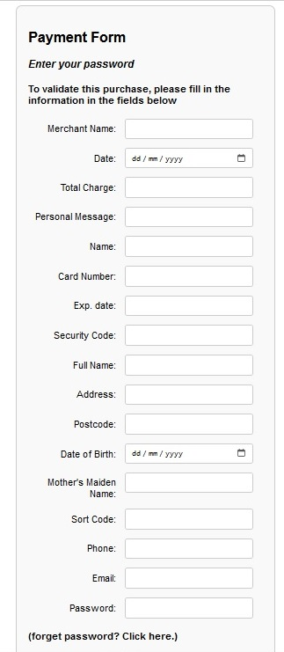

Bench Note John Anderson #1
Date: April 12, 2014
Time: 11:26 AM
Subject: Alex Smith (Case Reference Number: 201404002) The Process Tree
Attachment: Exhibit A
I analysed the RAM image obtained from Alex's Dell OptiPlex specifically the process tree. Of note is a process named vijene.exe so I investigated it further.
1. I could not find any association for vijene.exe with any known system or user applications. This raises immediate concerns about its legitimacy.
2. The process vijene.exe (PID 1688) is a child process of explorer.exe (PID 1240). While explorer.exe is a standard Windows process responsible for handling the graphical user interface, it is uncommon for it to spawn processes with such names that are not part of standard operations or known applications.
3. The unusual naming and the context in which vijene.exe is running suggest that it might be part of malicious activity. Malicious software often uses random or misleading names to avoid detection.
Further analysis is required
Exhibit A
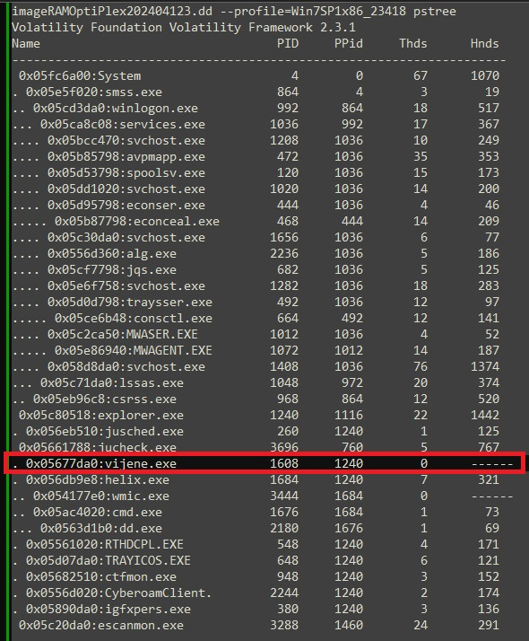

Bench Note John Anderson #2
Date: April 12, 2014
Time: 2:45 PM
Subject: Alex Smith (Case Reference Number: 201404002) Network Connections
Attachment: Exhibit B
I analysed the network connections and noted that explorer.exe (PID 1240) had established an external network connection to IP address 24.177.33.91. This is unusual because explorer.exe typically does not initiate network connections, especially to remote IP addresses.
The analysis also revealed that the IP address of Alex's Dell system was 111.112.113.52, which may have been altered. An IP address lookup indicated that 111.112.113.52 is associated with China Telecom - NINGXIA, suggesting a connection to a foreign entity. This raises concerns about sensitive information potentially being sent to an illegitimate third party.
Exhibit B
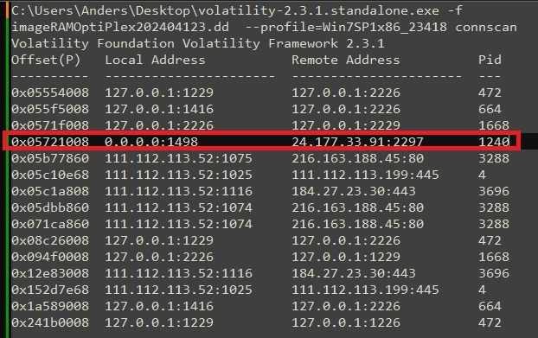

Bench Note John Anderson #3
Date: April 21, 2014
Time: 3:01 PM
Subject: Alex Smith (Case Reference Number: 201404002) Process Integrity
Attachment: Exhibit C
The network connections and IP address changes led me to use the malfind plugin to analyze the memory snapshot of Alex Smith’s system. The analysis revealed several suspicious processes, including explorer.exe, jucheck.exe, igfxpres.exe, and jusched.exe, all of which showed signs of being compromised by malware. These processes were flagged with a high detection ratio on VirusTotal, indicating the presence of the "Zeus Gameover" malware, known for hijacking system processes and stealing sensitive information during online transactions.
Exhibit C
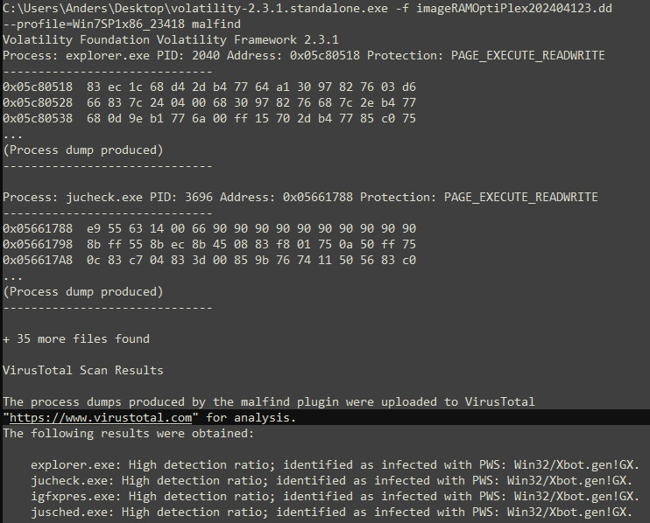

Bench Note John Anderson #4
Date: April 12, 2014
Time: 3:45 PM
Subject: Alex Smith (Case Reference Number: 201404002) IP Address Update
Attachment: Exhibit D
I can confirm that the IP address was updated. Using the Volatility printkey command, I extracted the registry key that logs the system's IP address changes. The records indicate that the IP address on Alex Smith's system was updated to 111.112.113.50 on April 1, 2014, at 02:02:53 PM. This change is suspicious and aligns with the timeframe of the malware infection, suggesting the attacker may have altered the IP address as part of their efforts to maintain control over the compromised system.
Exhibit D
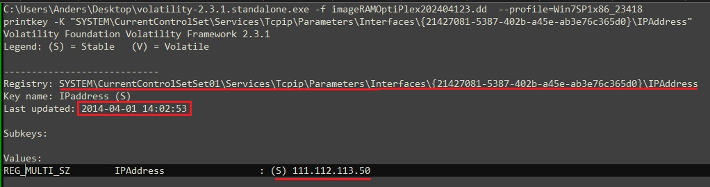

Bench Note John Anderson #5
Date: April 12, 2014
Time: 4:04 PM
Subject: Alex Smith (Case Reference Number: 201404002) Firewall Settings
Attachment: Exhibit E
Further registry analysis using Volatility's printkey command showed that the Windows Firewall was disabled on April 1, 2014, at 02:46:53 PM. The registry key EnableFirewall was set to 0, which effectively turned off the firewall. This disabling is characteristic of the PWS: Win32/Xbot.gen!GX malware, which often disables security measures to facilitate data exfiltration and other malicious activities.
Exhibit E
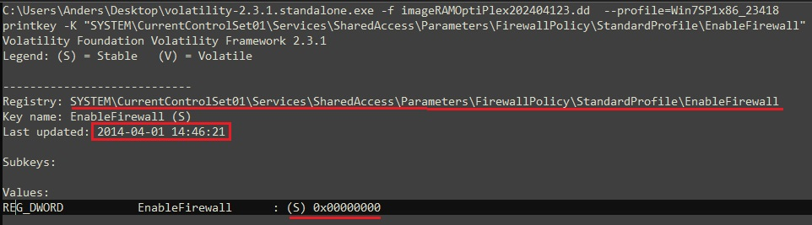

Bench Note John Anderson #6
Date: April 12, 2014
Time: 4:15 PM
Subject: Alex Smith (Case Reference Number: 201404002) Event Log Analysis
Attachment: Exhibit F
I examined the Windows event logs using Autopsy 3.0.9 and identified a key event where the Quick Heal Total Security antivirus software was uninstalled from Alex Smith's system. This event occurred on April 1, 2014, at 11:49:36 AM, shortly before other security measures were compromised. The removal of the antivirus software indicates that the attacker took deliberate steps to eliminate defences that would have detected or blocked the malware’s activities.
Exhibit F
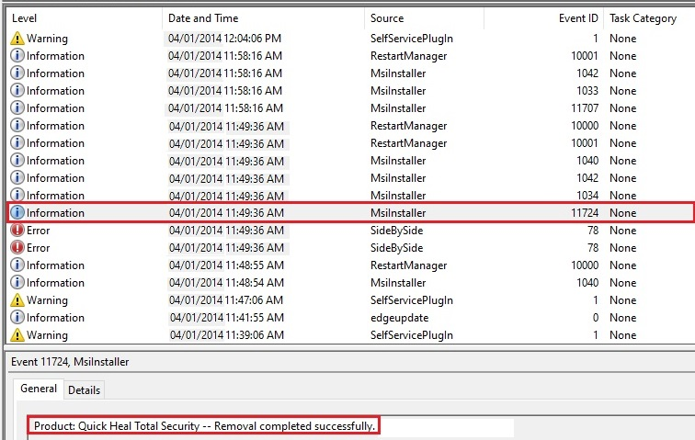

Memo 2 from John Anderson
Date: April 13, 2014
Time: 9:05 AM
Subject: Alex Smith (Case Reference Number: 201404002) Machine Infection
Attachment: Chain of Custody Table
The expert analysis indicates that the infection likely occurred through a malicious download, such as a file disguised as legitimate software but containing harmful code. During the investigation, no evidence of an outlook.exe process was found on the system, suggesting that the infection did not originate from an email attachment
Here is the chain of custody you will need this for your report
(see below)

Dell OptiPlex PC (Alex Smith's Home Office)
Consultant (Name/ID#) John Anderson, ID# 1457
Client: XYZ Bank
Auditee: Dell OptiPlex 9020 used by Alex Smith
Date/Time of Custody: 11:05 am, April 8, 2014
Location of Seizure: Alex Smith's Home Office 12 Station St Chatswood
Description of Evidence
Item # | Quantity | Description of Item (Model, Serial#, Condition, Marks, Scratches
1 | 1 | Dell OptiPlex 9020 - HDD Model: Seagate Barracuda 7200.12
 |  | Serial NO: Z1E4G7R9
 |  | Size 500GB
 |  | RAM: 8GB (2x4GB DDR3 Modules)

Chain of Custody
Item# | Date/Time | Released by | Received By | Comments/Location
1 | 11:00 am  8 April 2014 |  |  | I confirmed that the PC was not accessed prior to imaging.  Impact on data integrity N/A  Impact on deleted artefacts N/A  Location: PC was not moved. PC was turned on at the time of arrival.  Imaging Details:  Hard Disk imaged using FTK Imager 3.2.  - RAM image captured using FTK Imager 3.2 , 8GB (2x4GB).  - Imaging started at 11:15 am and completed at 12:25 pm.
1 | 12:25 pm 8 April 2014 |  |  | Image obtained using FTK Imager:  - HDD Image Size: 500,107,862,016 bytes  - 0 bad sectors found  MD5 Hash of HDD Image: d65c0d5f328f328fbea0ff1b450ce8f2204  RAM Image Size: 8,589,934,592 bytes  MD5 Hash of RAM Image: 74accc3d8faeeffbd09a2c3fc9e7bd5d  Time of Image Completion: 12:25:58 pm

